Saint Louis University

School of Accountancy Management and Computing Information Studies

Web System and Technology (S.Y. 2018 - 2019)

USER MANUAL

CMS (Wordpress)

9461B IT 324L

2:30-4:00 MTh

**Submitted by:**

Hilarion, Bill Lenard

Ocampo, Larry Roger

Torres, Derwin Armanny

Manahan, Anne Claudette

Poyaoan, JM Camille

Tuguinay, Mikka

November 05, 2018

Table Of Contents

1. Main Page………………………………………………………………………………3
2. Getting to know the website…………………………………………………………..3

Getting to know the website…………………………………………………………..4

Getting to know the website…………………………………………………………..5

1. Log in/Register/Edit Account………………………………………………………….5

Log in/Register/Edit Account………………………………………………………….6

Log in/Register/Edit Account………………………………………………………….7

1. Function of different widgets and websites………………………………………….7

Function of different widgets and websites………………………………………….8

Function of different widgets and websites………………………………………….9

Function of different widgets and websites…………………………………………10

1. **Main Page of the website**
2. Simply type in the domain name which is ***“sicap.slu.org”*** to go to the main page of the website.



*Figure 1. “Domain name of the website”*

b. After you type the domain name which is ***“sicap.slu.org”*** in a web browser the main page will be shown.

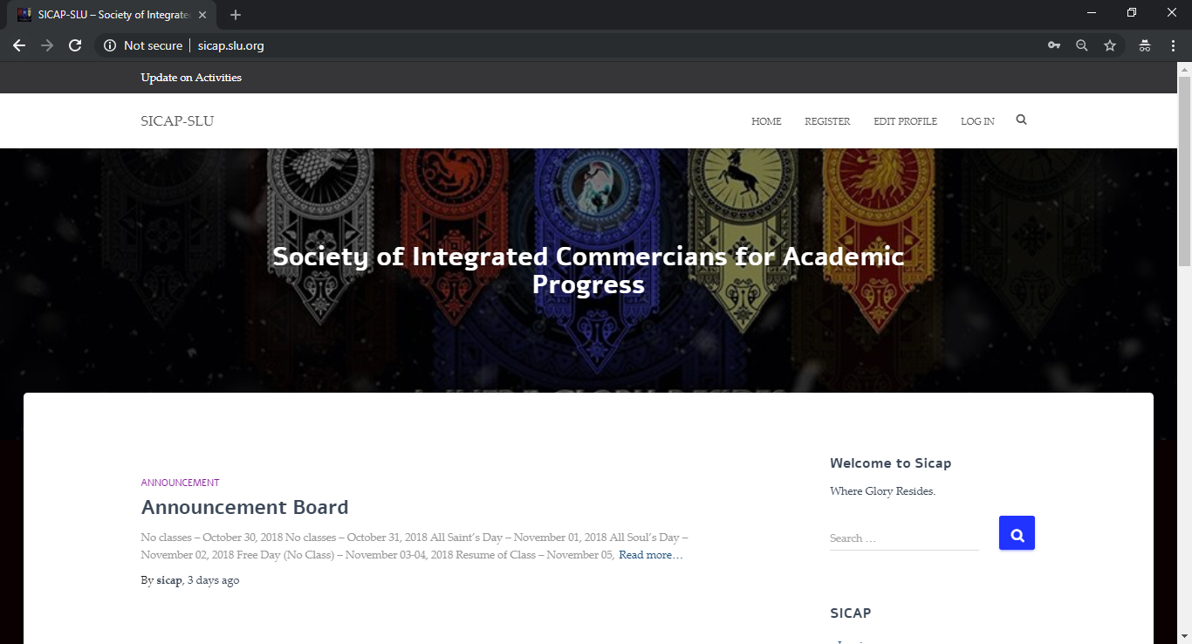

*Figure 2. “Main page of the website”*

**II. Getting to know the website**

1. You will see above this above the website. Update on Activities, home, register, edit profile and login is shown at the menu header.



*Figure 3. “Menu Header”*

b. When we click the home button. We will see the Announcement and

Information board.

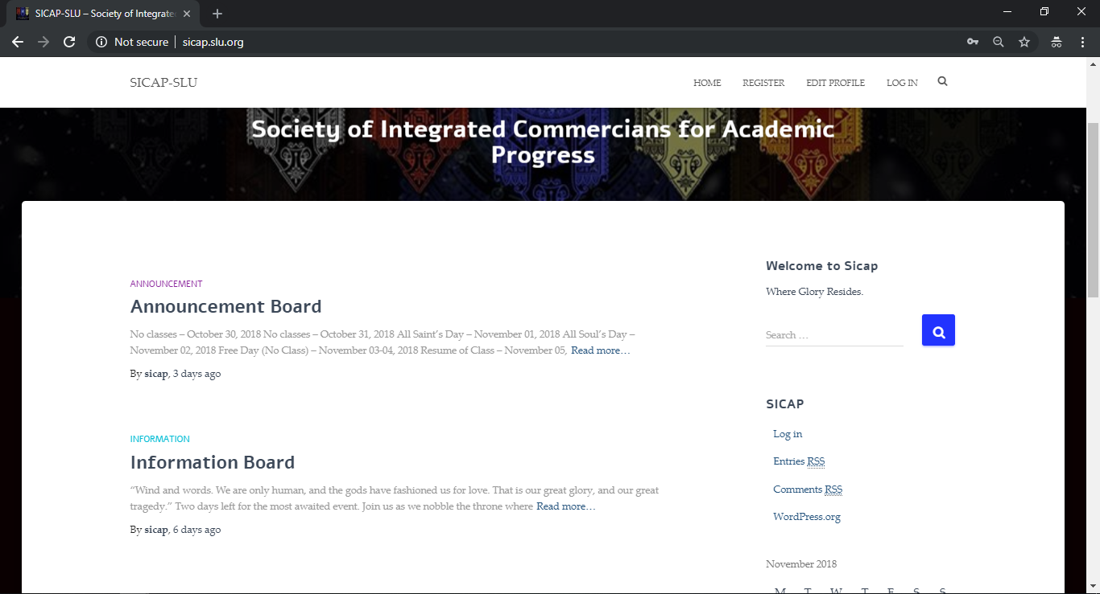

*Figure 4. “Announcement and Information board”*

c. At the side of the homepage we can see the Welcome sign of SICAP, the

search bar, calendar, camera roll, forum and login field.

*Figure 5. “Calendar, The search bar, calendar, camera roll, forum and login field.”*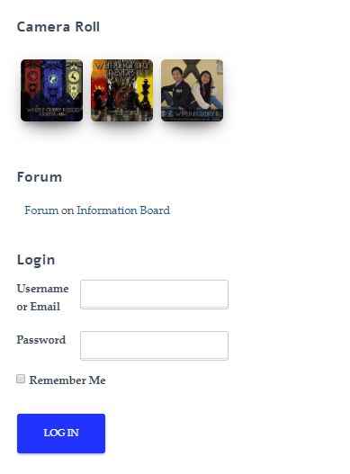

d. At the footer, you can see where SICAP can be found and you can also

see here the updates on their previous activities.

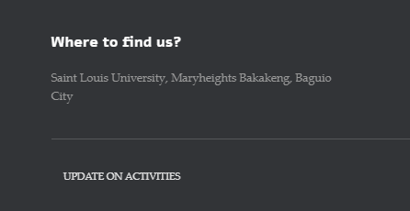

*Figure 6. “Where to find us?”*

**III. Login/Register/Edit an account**

1. If you have an existing account you can login by clicking the login button at the navigation bar or use the login field located at the right side of the home page.

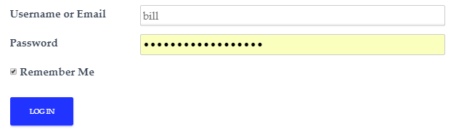

*Figure 7. “Login”*

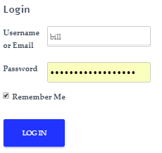

*Figure 8. “Login”*

b. But if you have no account, you can register. Just click on the register button

and the necessary information. Take note that field (*) is required to have an

Input.

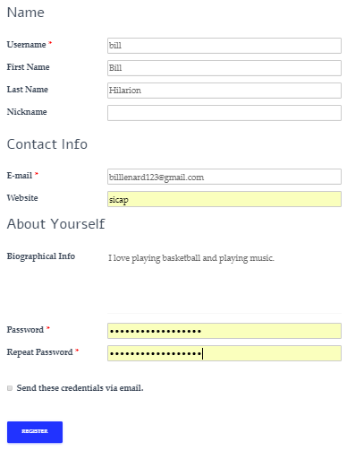

*Figure 9. “Registration Form”*



*Figure 10. “Confirmation for creating an account”*

c. You can also edit your profile, if you want some changes.

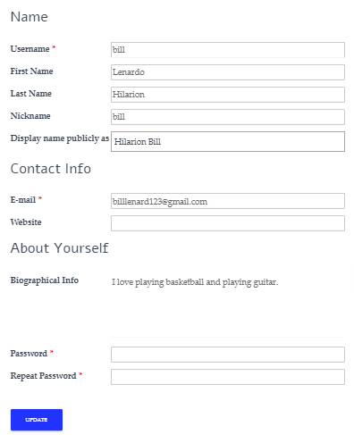

*Figure 11. “To edit your profile”*

**IV. Function of different widgets and pages**

a. At the homepage, when we click on announcement board, we are able to

see the announcements that are made by the school and organization.

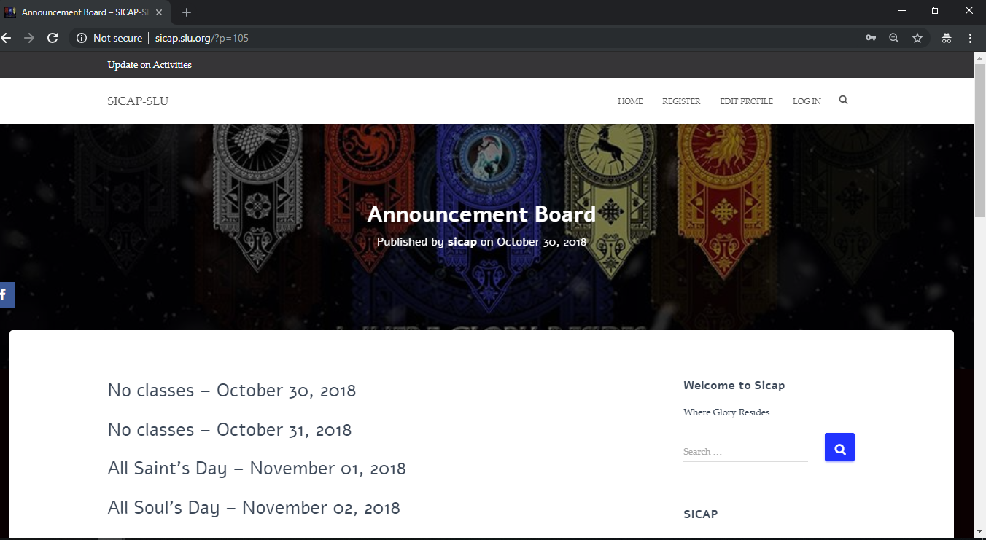

*Figure 12. “Sample Announcement”*

b. We can also see the homepage in the information board. When clicked,

Information about the organization is posted.

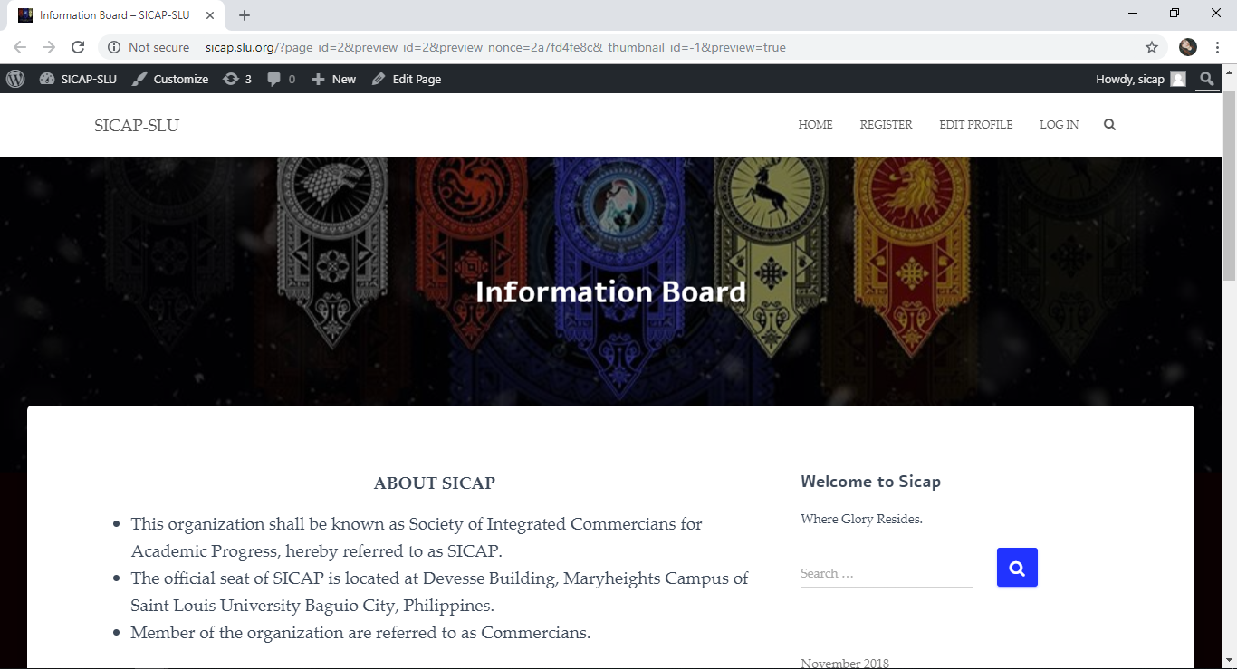

*Figure 13. “Information about the organization”*

c. There is also a feature included wherein we can also see images of the said

organization.

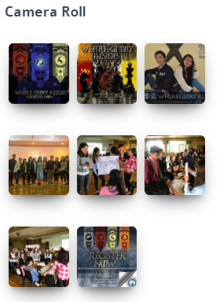

*Figure 14. “Camera Roll”*

d. We also have the Forum feature where members are free to express

themselves. This section is also similar to a comment section.

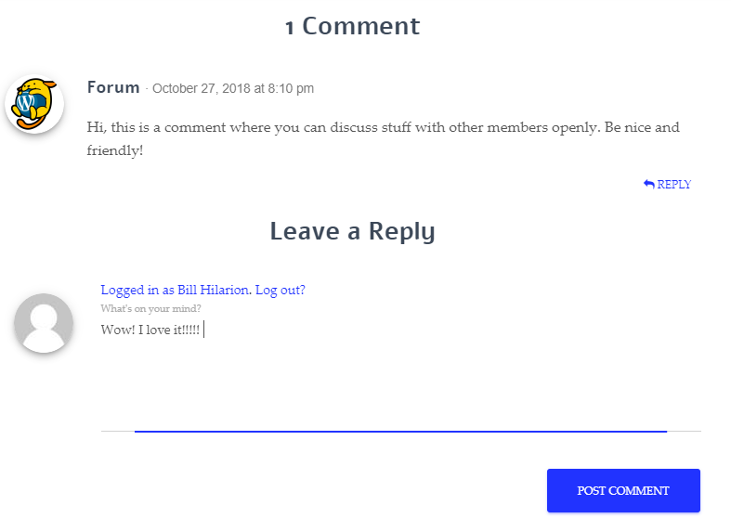

*Figure 15. “Comment Section for Forums”*

e. Members are always updated. By clicking on the *‘Update on the Activities’*

you will see images and feedback on the previous events hosted by the

organization.

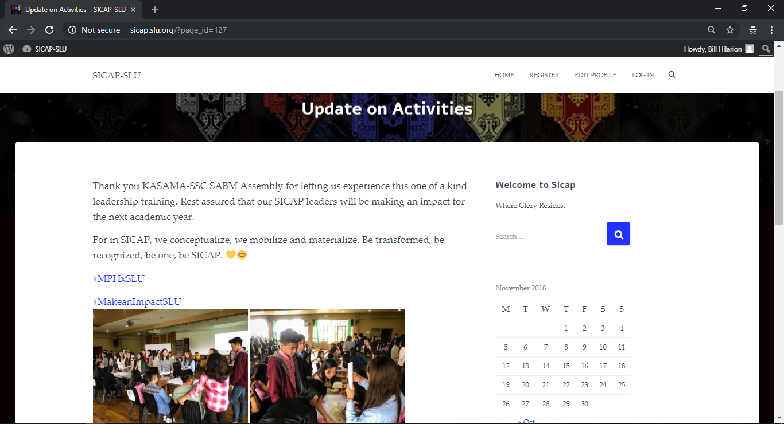

*Figure 16. “Updated Activities”*

f. Social medias are links are also included such as Emails, Facebook, Twitter

and Instagram.



*Figure 17. “Social Media Links”*